User Manual

5e Character Forge Application

Table of Contents

1. Overview3
2. Getting Started3
3. Character Creation4
4. Character Maintenance4
5. Maintaining Settings6
6. Additional Items / Frequently Asked Questions7

# Overview

In Dungeons and Dragons, or D and D for short, players use character sheets to track their important information regarding their in game character (such as name, level, stats, and skills). Unfortunately, these character sheets are primarily in print, and those few online compatible character sheets are subpar at best. This makes it more tedious and time-consuming, since players are required to monitor their characters in a manual style, as they need to perform actions such as leveling up, monitoring currency, and rolling dice. In order to combat this problem, the 5e Character Forge application was created. This application places emphasis on being able to monitor created characters in an efficient manner. In addition, 5e Character Forge allows for the storing and managing of multiple characters, making it easier to keep track of characters if one is playing multiple games without having to keep track of physical pieces of paper. This application is supplemental to the D and D 5th edition player’s handbook, created by Wizards of the Coast. As such, the application serves to replace only the character sheet used to track character progression, not the book itself. The following documentation describes how to use the application, which includes, but is not limited to, launching the application, creating characters, and frequently asked questions.

# Getting Started

1. Launch Screen

When beginning the 5e Character Forge application, the user is brought to a splash screen:



The user can continue by pressing any key, which will redirect him or her to the start menu of the application.

1. Start Menu

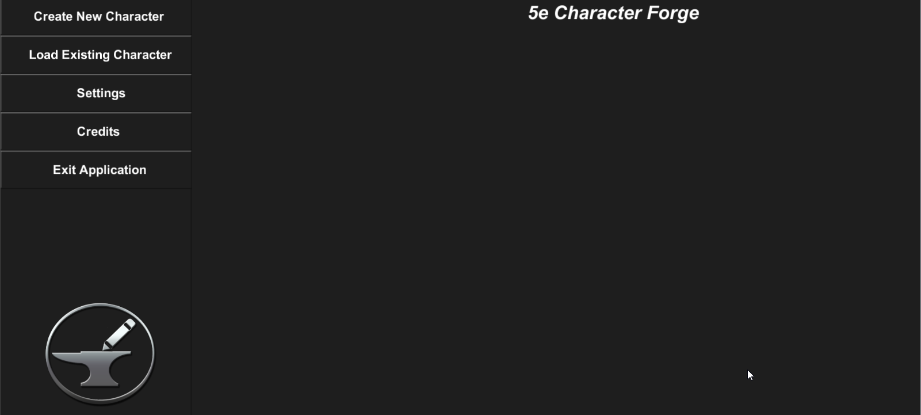

While in the start menu, the user has the following options:

* Create New Character – begin the creation process for a new character
* Load Existing Character – load all saved existing characters so the user may select which one to load
* Settings – screen in which the user can maintain universal settings, such as background music volume and whether the application mode is online or offline
* Credits – acknowledgements in regard to who worked on the application and crediting others for the use of their resources
* Exit Application – enables user to end the application

1. Credits

In order to view the credits of the application, the user can select the credits button in the start menu (see below).

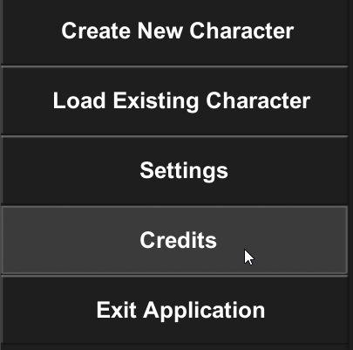

While viewing the credits, the user can opt to go back to the start screen or wait until the credits finish rolling to be automatically returned to the start screen.



1. Exit Application

In order to exit the application, select the “Exit Application” button and select “Yes” in the popup which appears to confirm the ending of the application.

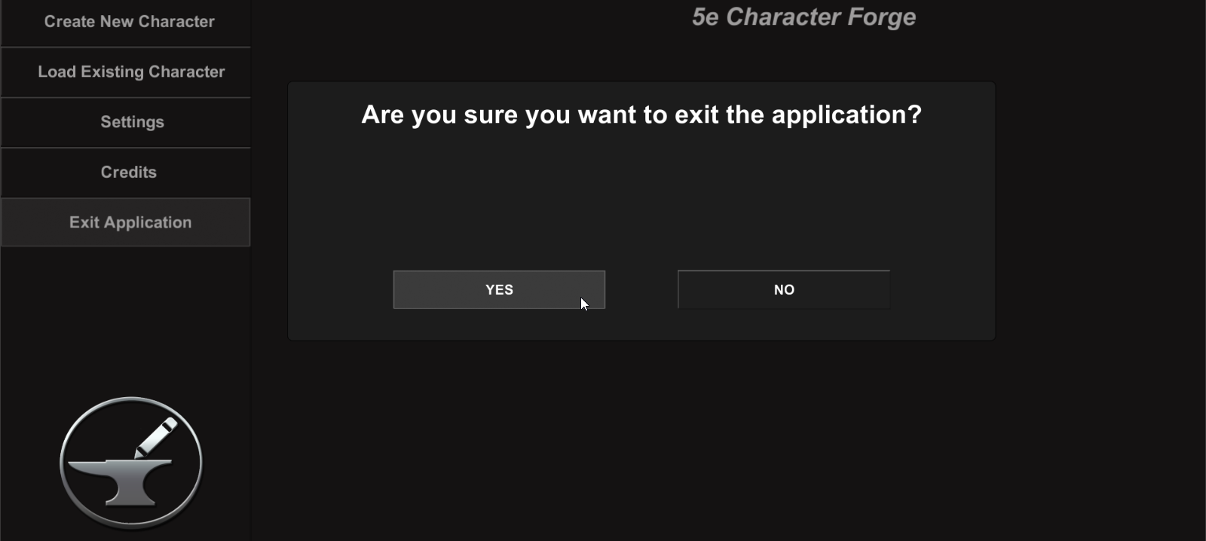

# Character Creation

After selecting the Create New Character button in the start or pause menu, the user will be directed to a new set of screens for character creation.

1. Uploading an Avatar

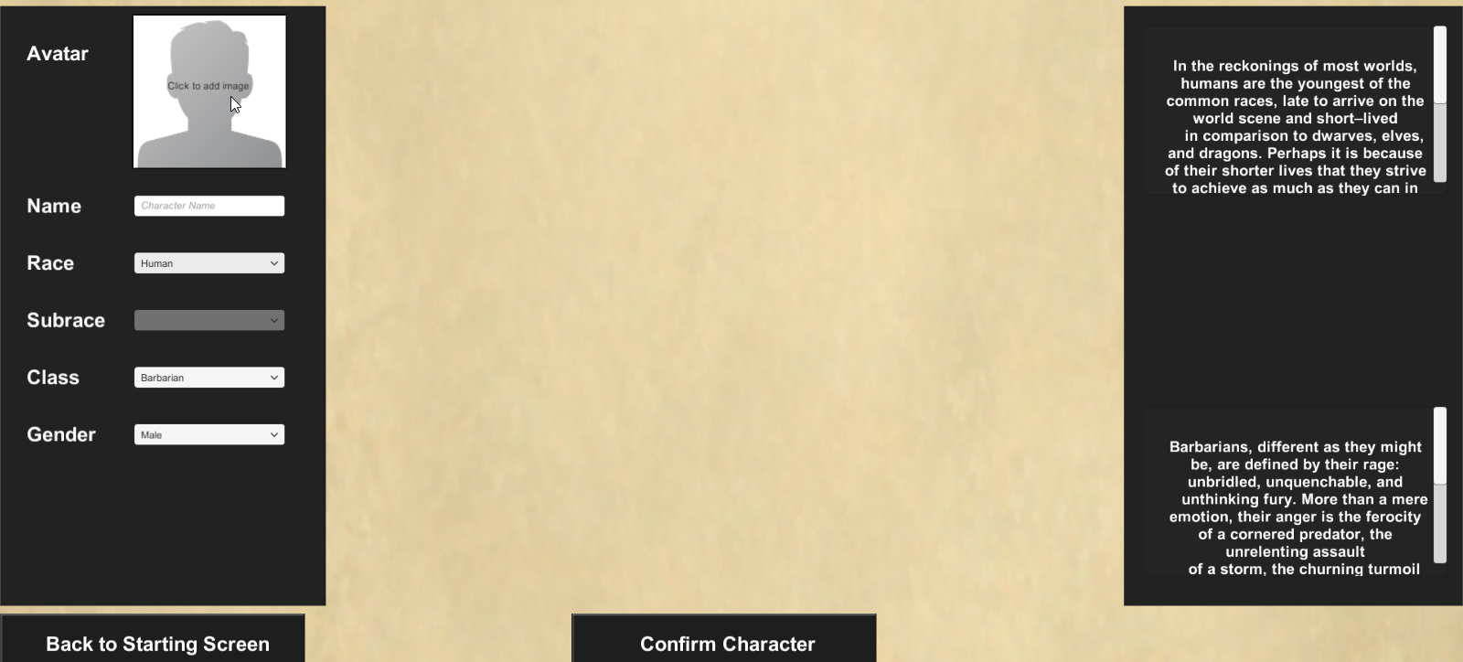In order to upload an avatar image, the user clicks on the avatar image (see below) to display a popup.

Within this popup, the user can either upload an avatar image from a URL or from a local file on his or her device.

* Via URL – enter the URL of the image and select the Upload button next to the URL field
* Via File – click the Browse button to search for the image to upload, select the image, then select the Upload button to the right of the Browse button

Alternatively, the user can exit out of the uploading process by selecting the Cancel Upload button.

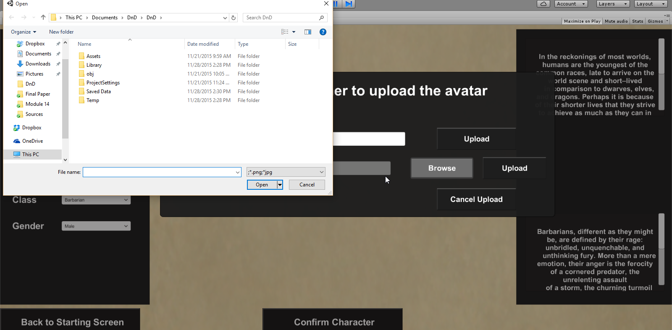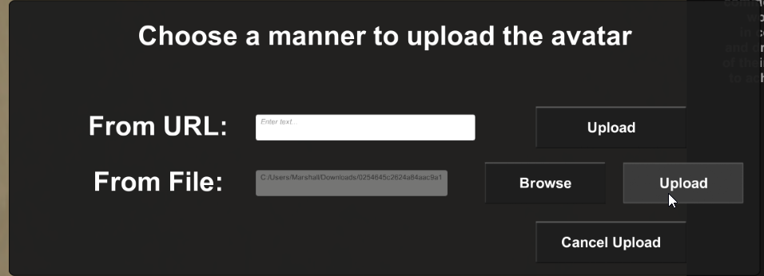



1. Enter Character Name

Enter a name for the character.

1. Select Race and Subrace

Select a race for the character. This selection will affect the character’s ability scores, proficiencies, and languages.

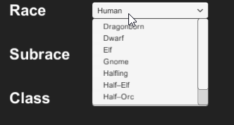

If the selected race has a subrace, then select a subrace for the character as well.



1. Select a Starting Class

Select a starting class for the new character. The character’s class will affect the spells they can learn, health, proficiencies, etc.

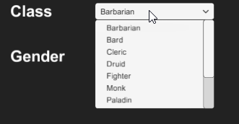

1. Select a Gender

Select a gender for the class (Male, Female, or Other).



1. Enter Ability Scores­­­­­­­­­

The next main part of the character creation process is to enter the starting ability scores of the character, which represent different stats (such as strength, wisdom, charisma, etc.).

There are two ways in which users can maintain ability scores:

1. Rolling for Stats
2. Point-Buy Calculator
3. Confirm Character

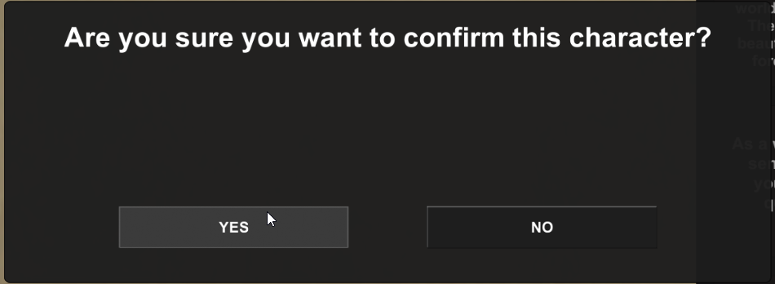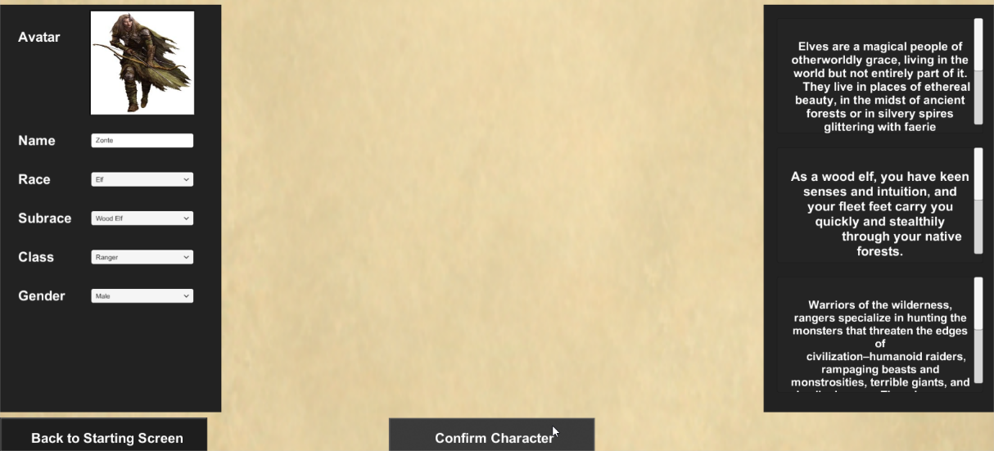To confirm the character creation process, select the Confirm Character button and select Yes in the popup which displays to confirm the character.

# Character Maintenance

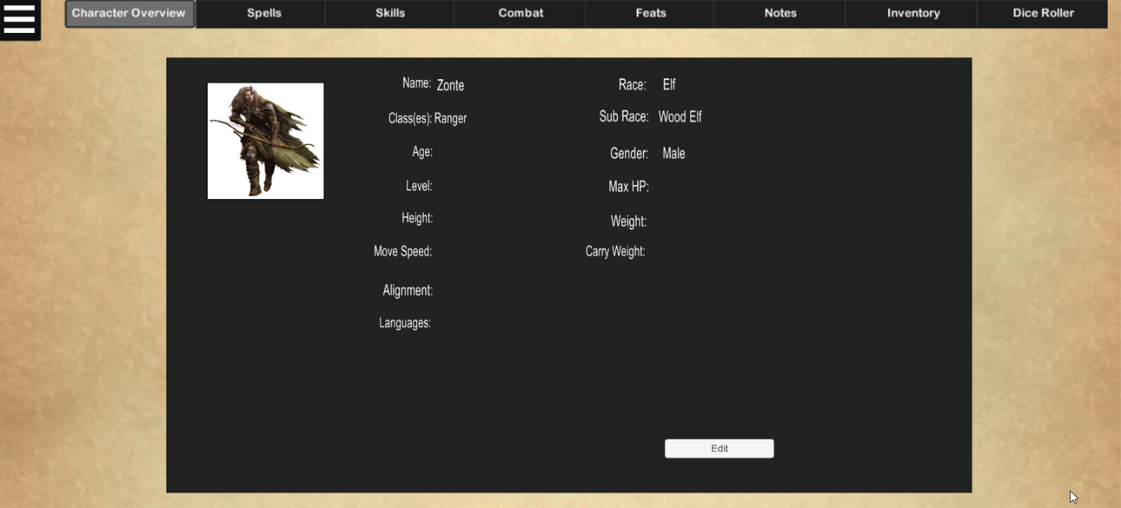

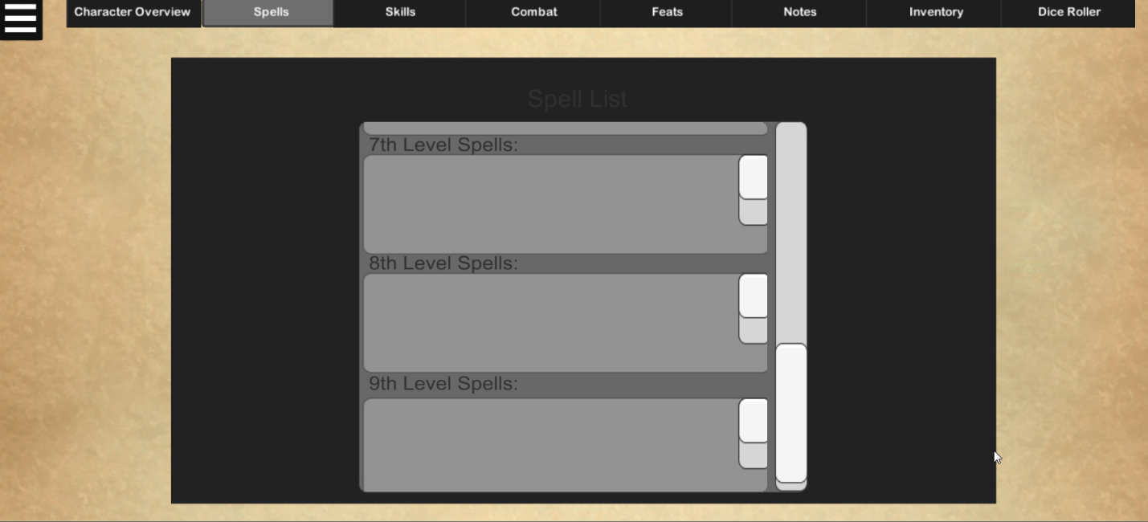

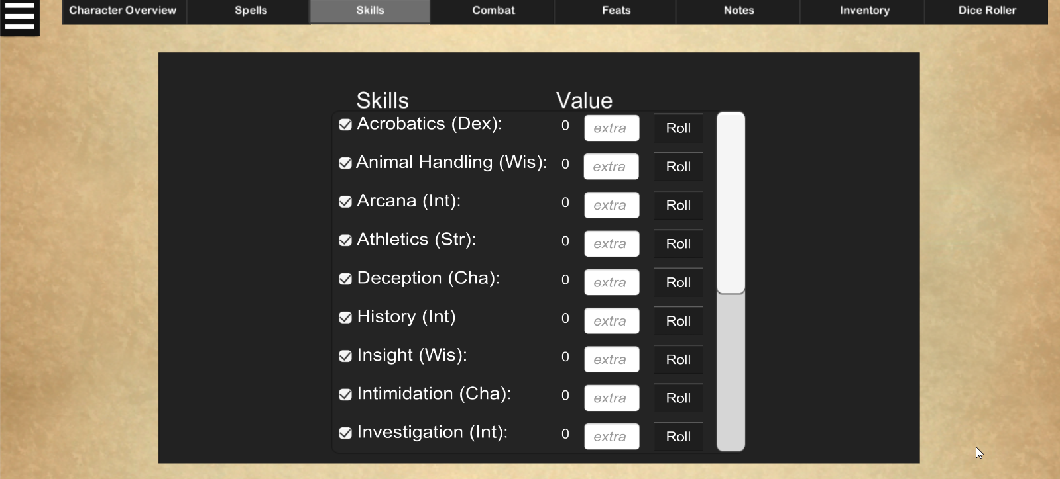

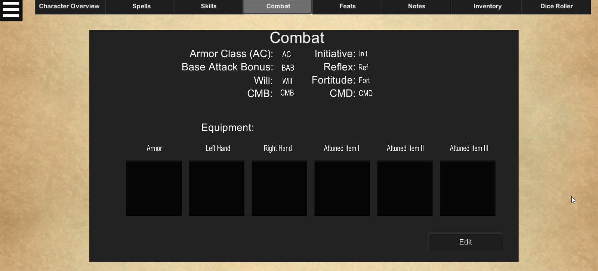

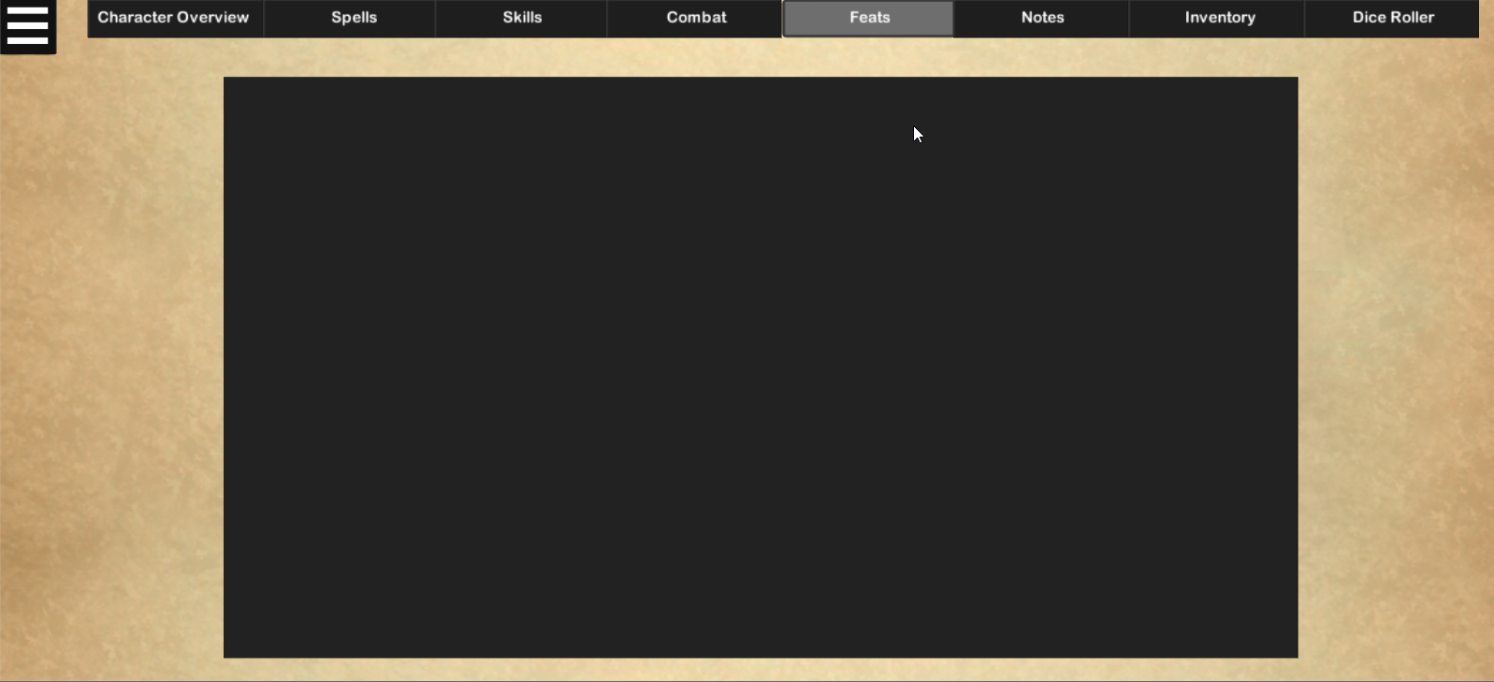

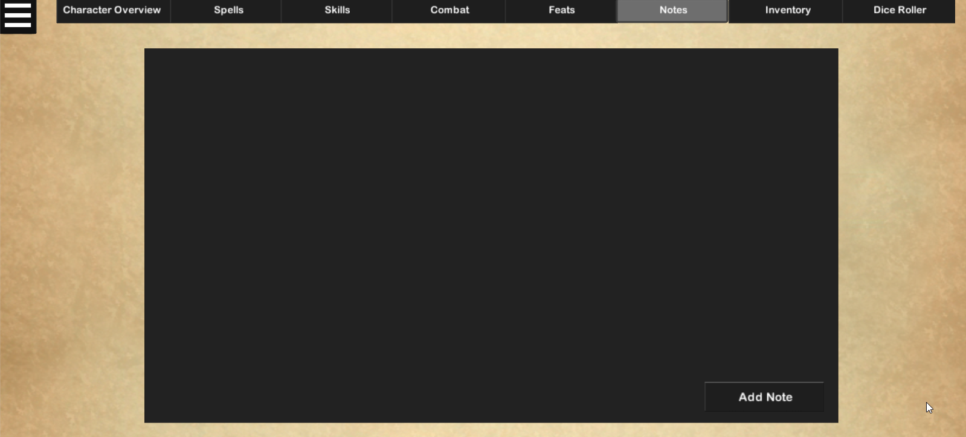

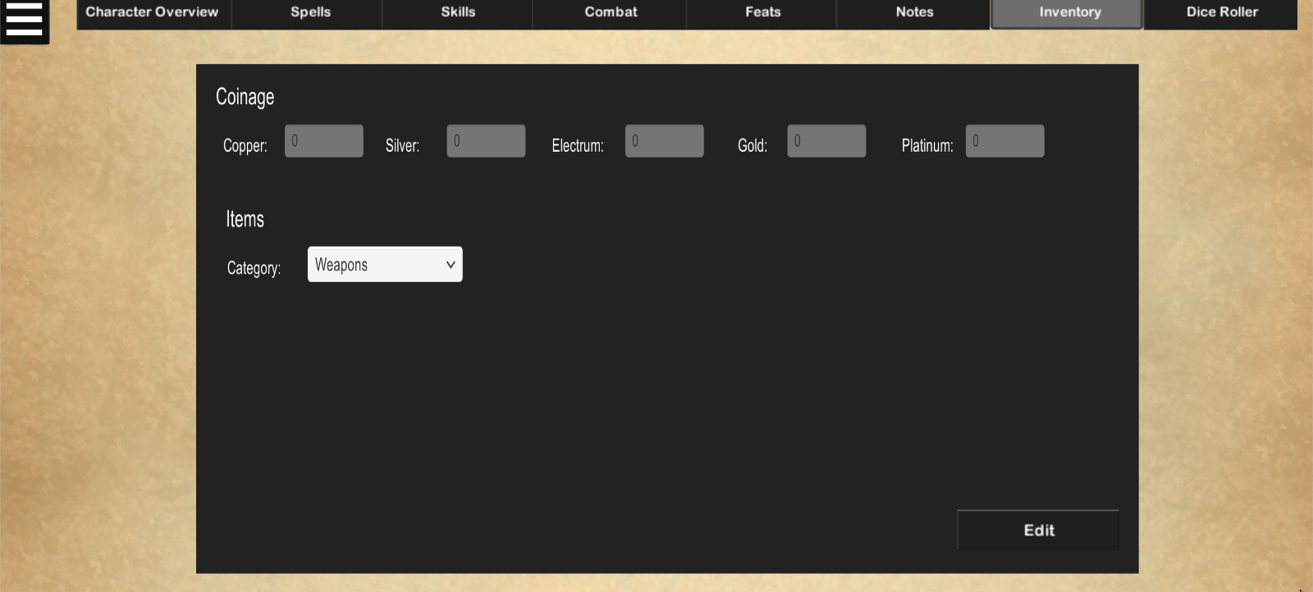

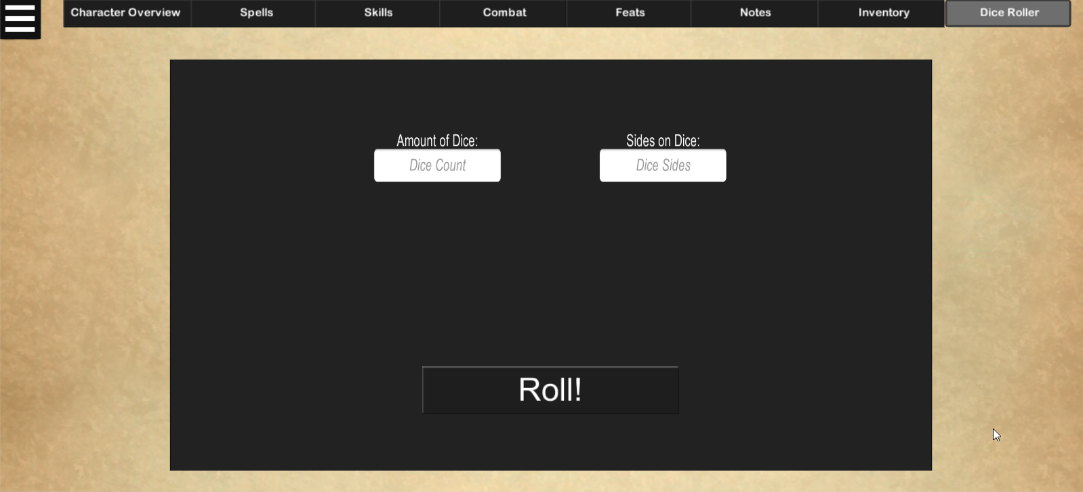

 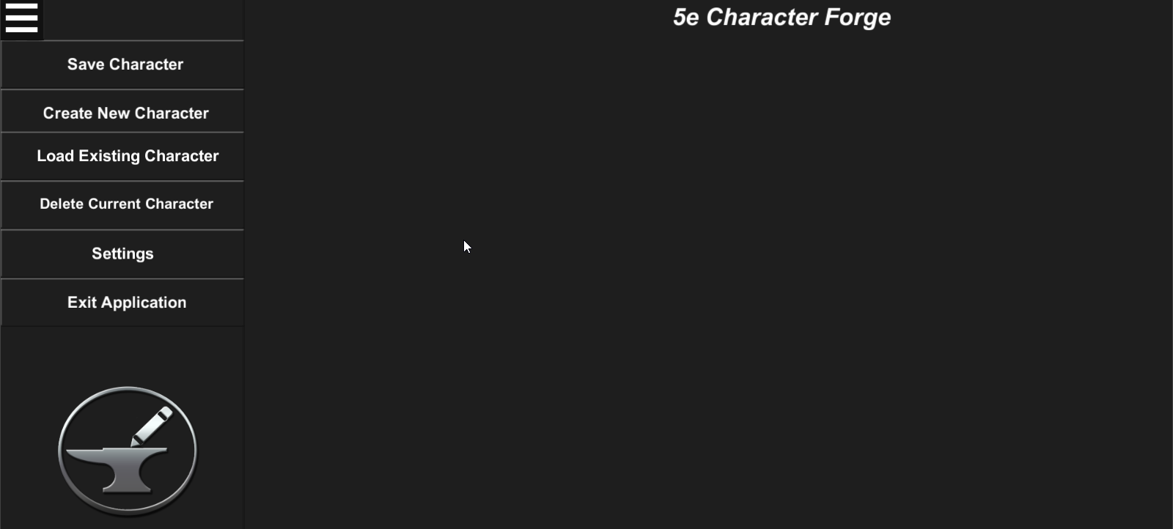



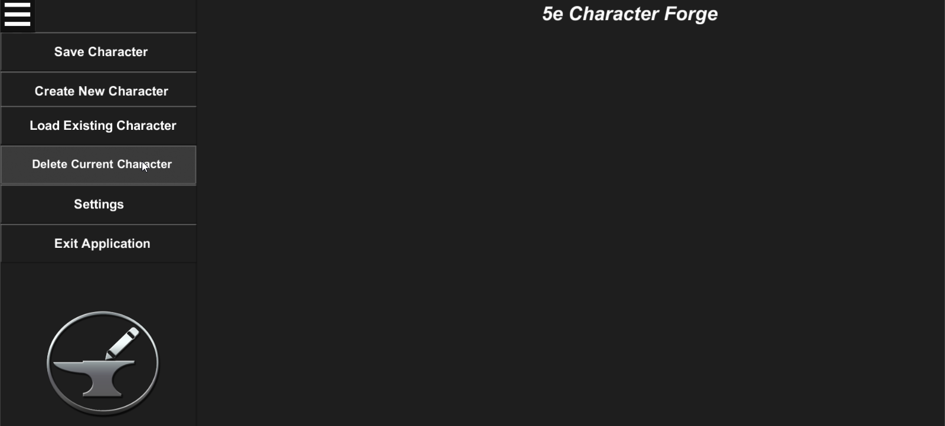

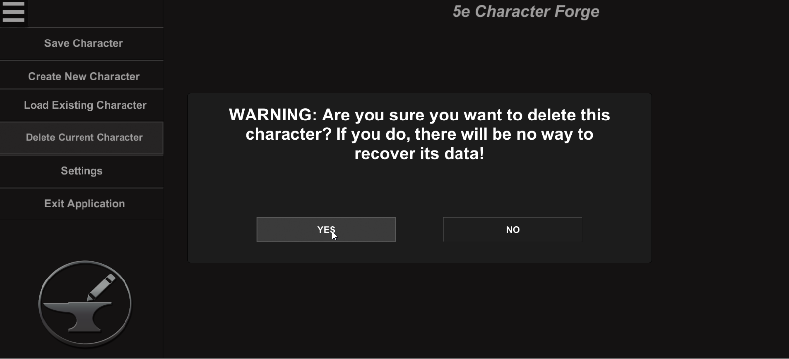

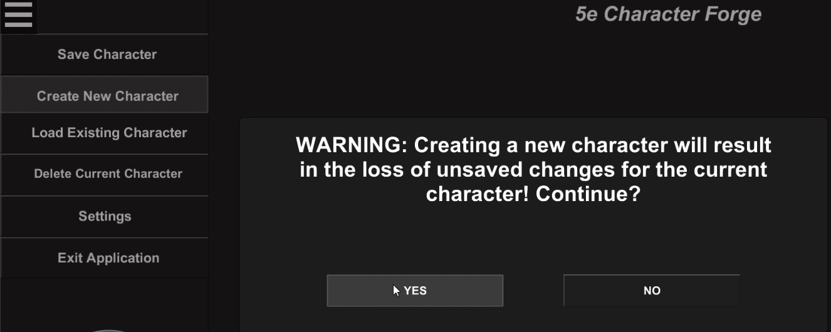

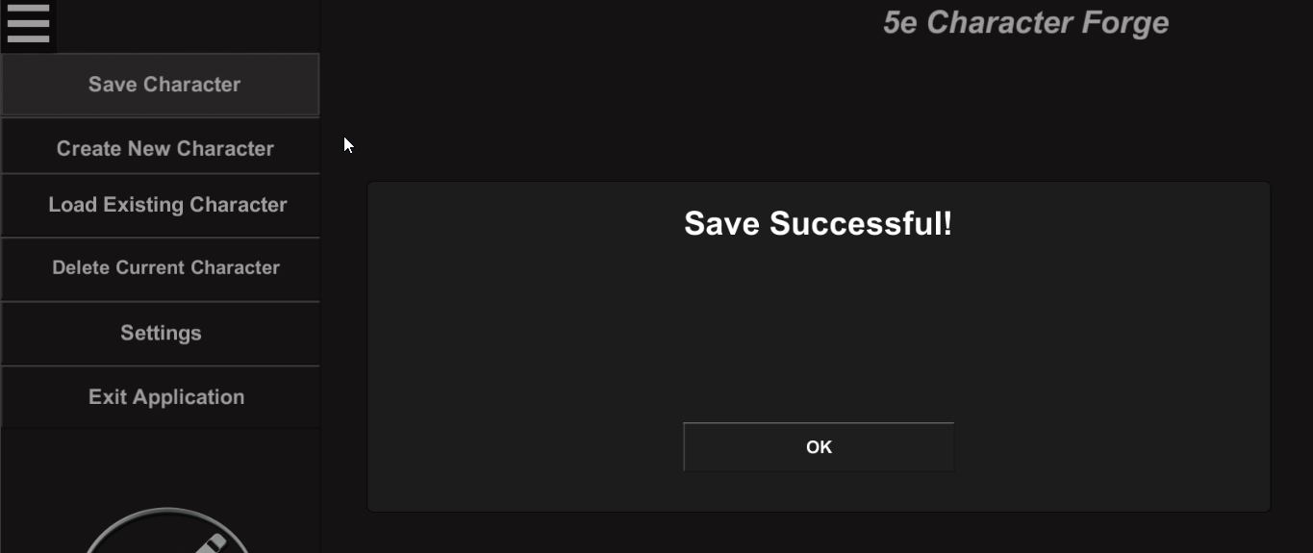

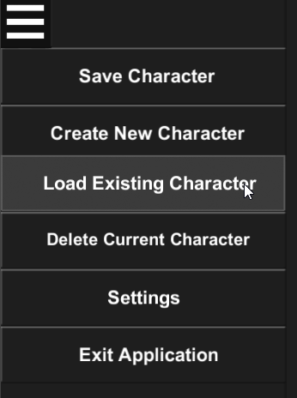

# Maintaining Settings

In order to maintain universal settings, the user can select the Settings button in either the pause or start menus.

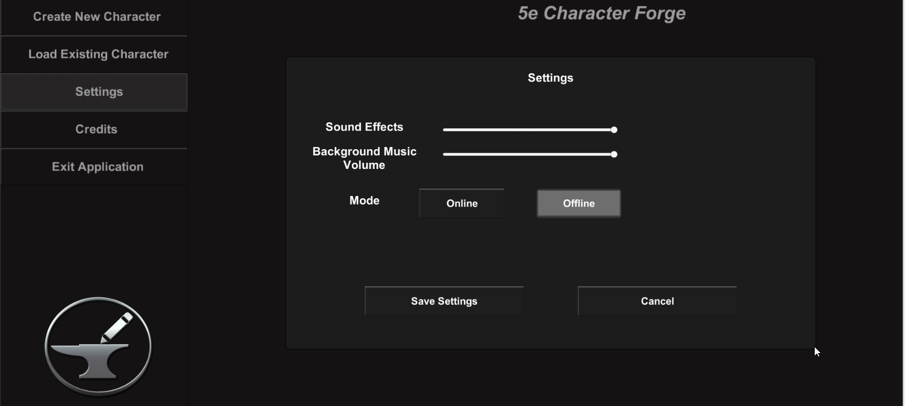  
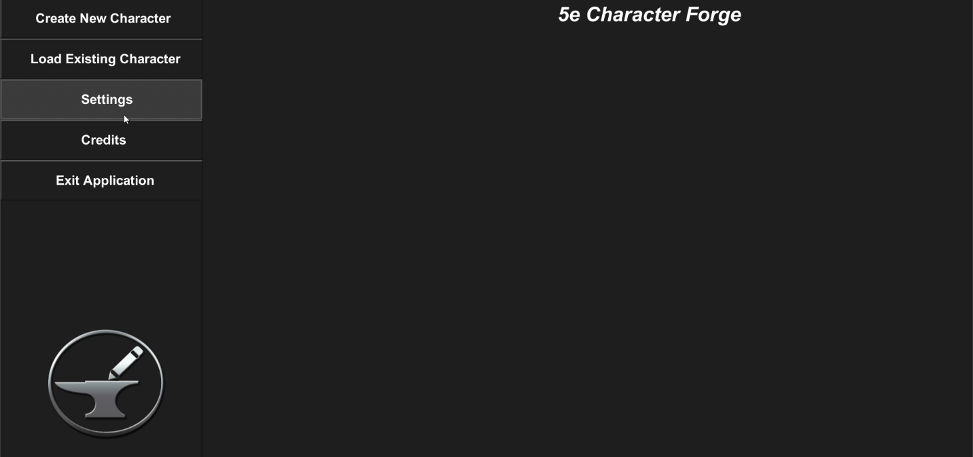From here, the user can adjust the application’s volume for the background music, volume for sound effects (such as button clicks and alert notifications), and change the mode to either online or offline.

To adjust the volumes, use the corresponding sliders in the settings menu. Moving the slider left will decrease the volume, while moving the slider to the right increases the volume.

There are two modes for the 5e Character Forge application:

* Online – data retrieved from external resources (such as the class, race, and spell descriptions) will be retrieved from the internet
* Offline – data retrieved from external resources will be retrieved from local files which are stored on the computer (allows for offline use in case the user loses his or her internet connection)

When a mode is selected, the user will be warned of how the change will affect the application:

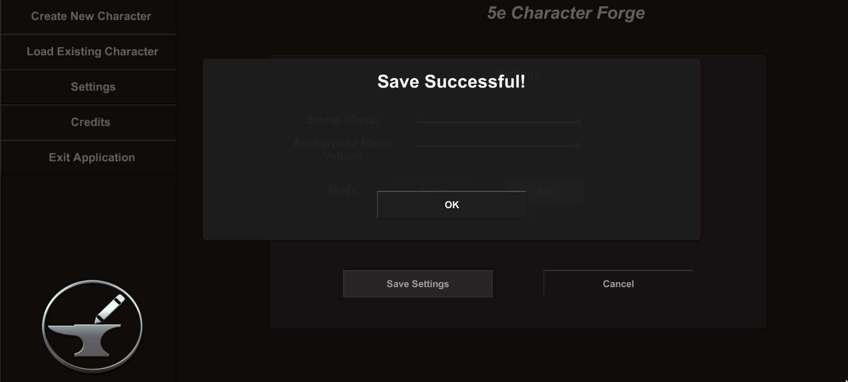Once the user is satisfied with his or her changes, he or she can save said changes by pressing the Save Settings button:

Alternatively, the user can cancel changes by selecting the cancel button.

# Additional Items / Frequently Asked Questions